**Programming Fundamentals Lab Manual 6**

**Instructions:**

* Do your tasks individually **discussions are not allowed.**
* Anyone indulged in the act of plagiarism would be awarded zero
* Pay attention to details, do paperwork before starting your code.
* Understanding of the question is also part of the lab work.

**Objectives:**

In this lab, students will study:

1. Revise what we already learn.
2. Loops.
3. Nested Conditional statements.

**Task 1:** Generate a sequence where the next number is the sum of the previous two, similar to Fibonacci. However, if the position of number in the sequence is even, subtract it with the next number, otherwise add. The user provides the length of the series.

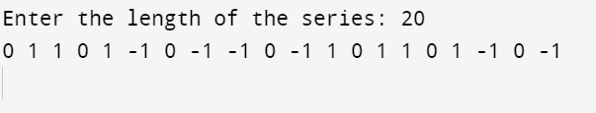

**Task 2:** Take a positive integer n from the user. If n is even and less than 10, multiply it by 5. If n is even and greater than 10, divide it by 2. If n is odd, multiply it by 3 and add 1. Repeat the process until reaching 3 or the 40 iterations are completed and print the sequence. Use the below method for output.

**Task 3:** Take an integer n from the user. For each number from 1 to n, display its divisors in a row. If the current number has an odd number of divisors, print "ODD" next to it; otherwise, print "EVEN".

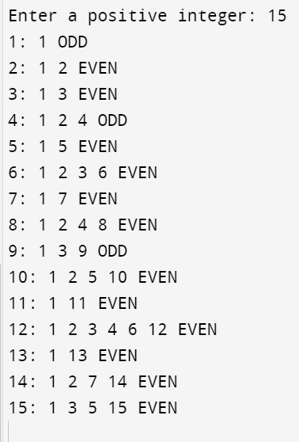

**Task 4:** Accept a number from the user. If the number is prime, multiply the digits together. If it's even but not prime, reverse the digits. If it's odd but not prime, calculate the sum of its digits. Display the result.

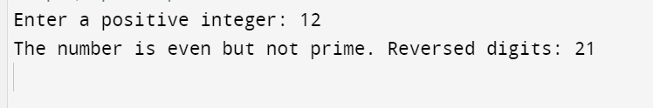

**Task 5:** Given a 3x3 matrix, if the matrix is a magic square, check if the matrix formed by the sum of each of its 2x2 sub-matrices is also a magic square. To determine if a 3x3 matrix is a magic square, we need to check that the sum of the numbers in each row, each column, and both main diagonals are the same. A magic square has the property:

**Sum of each row or column = n(n^2+1)/2, where n is the size of the matrix (in this case 3).**

If the 3x3 matrix is a magic square, we can then extract its four 2x2 sub-matrices and form a new matrix by calculating the sum of each of these sub-matrices. Finally, we will check if this resulting matrix is also a magic square.

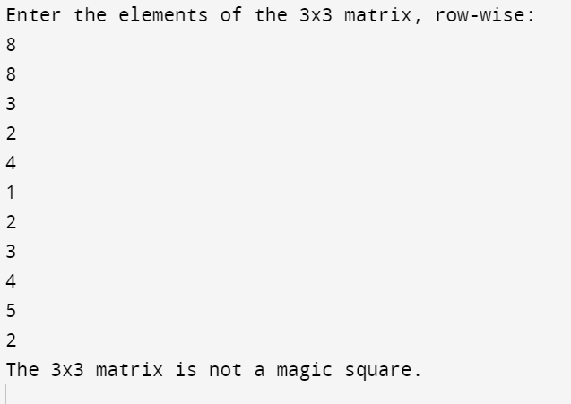

**Task 6:** **F**ind all numbers up to a given number n which are equal to half the sum of their divisors, and display them.

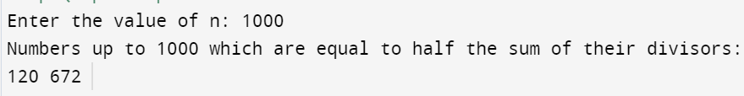

**Task 7:** Check if a given number is a palindrome. If it is, check if the number formed by its digits in ascending order is also a palindrome.

